**Making A Static Library**

Luke Plaisance

**Creating a Static Library**

First thing you should do is make a project to make the class in.Then Right click on the project and make you start up project. Have some simple math functions in their like add, subtract, multiply and divide and make sure it compiles using the “Local Windows Debugger.”.

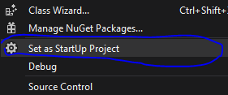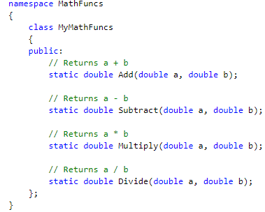

Next, you’d want to is make sure your project is in “Release” form. Also put it to x86 as well.

Next ,right click on your project you want to turn into a library and go down to properties. Once you’re there, click on “General” on the left tab and then find “”Configuration Type” under the Project Defaults. Click on the configuration Type and switch it to “Static Library.”

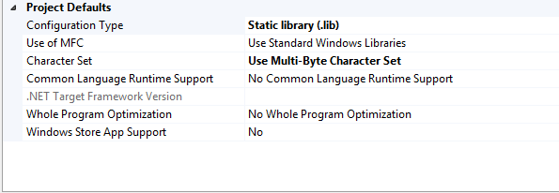

Click “Apply” then click “Ok”

Once you have that done, right click on your project again and click “build” to build the math library

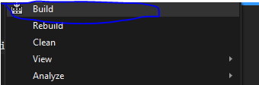

Once you’ve built the library, you need to go find the windows file explorer, then find the solution you want to link to your library.

**Linking a Static Library**

When you are in the solution you want to link, look for a folder that is named “dependencies.” If there isn’t one, make one.

Once you made the folder, make a new folder inside called “MathLib.” In that folder, make another folder called “Lib.”

Next, open up the windows file explorer again and find the project you built earlier. Now find the header files (.h) for the class you made earlier and put it in the “MathLib” folder. Then go the “Release” folder. There you should find the “.lib” file. Copy it, then put it inside the “Lib” folder from earlier.

Once that is done, open up the solution you are trying to link. Right click on your project and go down to properties. Once you’re there, you need to go to “VC++ Directories” tab on the left. Now you need to edit your “Include Directories” and “Library Directories.”

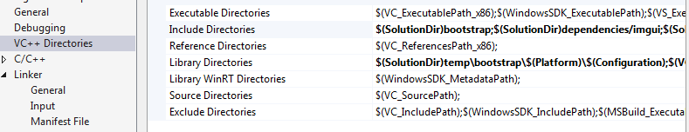

Once you are there, you need to click on the “Include Directories” and then click “Edit.” Then click on the folder icon and then find your “MathLib” folder and then click “Select Folder”. Once it is selected, take the folder that we just selected, and delete everything before the word “dependencies.”

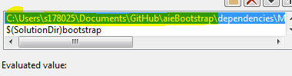

Now replace what you just deleted with “$(SolutionDir)” Then click “Ok”. Now for the Library Directories, find and select the “Lib” folder inside the “MathLib” folder. Do the same thing as the folder before by deleting everything before “dependencies.

Next, go back to your project’s properties and click on the “Linker” tab on the left. Then go to the “input” tab inside the Linker.

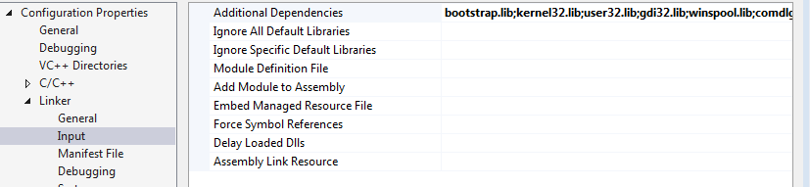

Click on the “Additional Dependencies”, then go to edit to enter a new file name. Enter the name of “.lib” file you made and include the “.lib” extension.

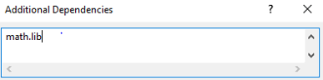

Click “Ok” then click “Apply” and “Ok” again the close the properties menu.

Once that is done, you should have everything completed. To use the library functions, use “#include” and the then name of the header file you want to put in.

